SPECIFICATION
Part Number: L.SLQ009
Part Description: Artwork, Label, Carton, 2-Way ClearTract SPT Catheter

Purpose

This document provides the artwork specification for the 2-Way ClearTract SPT Catheter Carton Label (L.SLQ009).

The final label artwork is maintained by Pathway (reference Pathway part number SLQ-AW-4009) as part of the overall device master record for the 2-Way ClearTract SPT Catheter.

Changes to the content of the label will be approved through Silq’s Document Control process. Once approved internally, Pathway is notified of the changes and will update the final label accordingly.

Supplier

Pathway LLC, 8779 Cottonwood Ave., Suite 105, Santee, CA 92071, Tel: (619) 415-0103.

Specification

Artwork Specification

Pathway Part Number: SLQ-AW-4009

Part Description: Artwork, Label, Carton, SILQ ClearTract Catheter

Label Artwork

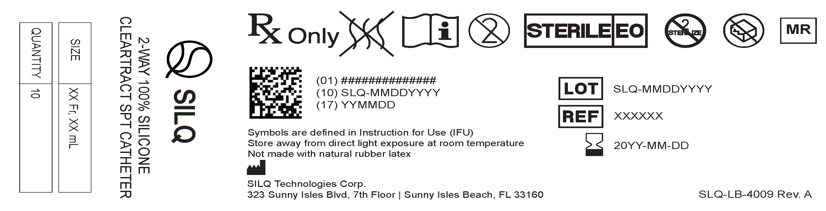

Attachments

SLQ-AW-4009_A.pdf (Pathway)

